**WP2: Development of training courses**

**Training course**

**QUALITY MANAGEMENT TOOLS**

**Final report**

**FOODQA partner:** Creative Thinking Development (CRE.THI.DEV.)

**Local Scientific coordinators:** Lina Tsakalou and Sofia Papakonstantinou (CRE.THI.DEV.)

Table of Contents

[1 Syllabus and Contents 3](#_Toc512621168)

[2 Planning and Organisation 5](#_Toc512621169)

[3 Training Course Timings 7](#_Toc512621170)

[3.1 Schedule 7](#_Toc512621171)

[3.2 Teachers 8](#_Toc512621172)

[4 List of Participants 10](#_Toc512621173)

[5 Signatures 11](#_Toc512621174)

[6 List of Additional Training Materials 14](#_Toc512621175)

[7 Assessment 15](#_Toc512621176)

[7.1 Training Assessment Questionnaire 15](#_Toc512621177)

[7.2 Assessment Results 19](#_Toc512621178)

[8 Pictures 20](#_Toc512621179)

[9 Training Evaluation 27](#_Toc512621180)

[9.1 Overall Conclusions 29](#_Toc512621181)

[10 Annexes 30](#_Toc512621182)

[Annex 1: Introduction to Quality Control (History & Definitions) 30](#_Toc512621183)

[Annex 2: Statistical Quality Control Part 1 30](#_Toc512621184)

[Annex 3: Statistical Quality Control Part 2 30](#_Toc512621185)

# Syllabus and Contents

**TITLE**: Quality Management Tools

**Teaching/contact time**: 16 hours

**A: Target group**

* Practitioners of the food chain sector
* Experienced professionals
* Undergraduates
* Master degree students, PhD

**B: Learning outcomes**

The aim was for trainees to be able to:

* Understand the basic principles of quality and quality management
* Understand the principles of Statistical Process Control
* Understand and use in processes the basic quality tools

**C: Minimum knowledge pre-requisites**

Minimum requirements (knowledge): Basic knowledge of statistics

**D: Contents**

|  | **Sub-topic** | **Teaching material** | **Reference person** |
| --- | --- | --- | --- |
|  | **Basic Quality Concepts**   * Basic Quality Definitions * History of Quality Control And Improvement | Powerpoint presentation , e-book | Ms Lina Tsakalou |
|  | **Statistical Quality Control**   * Statistics Used In Quality * Statistical Process Control * Acceptance Sampling * Design Of Experiments (DOE) | Powerpoint presentation, examples, e-book | Prof. Sotirios Bersimis |
|  | **Quality Tools**   * Check Sheets * Run Charts * Histograms * Scatter Diagrams * Pareto Charts * Flowcharts * Cause And Effect (Fishbone) Diagrams * Control Charts * Process Capability (Capability Indices) * Quality Costs | Powerpoint presentation, examples, e-book | Prof. Sotirios Bersimis |

**E: Complementary activities**

* A tour to the Agricultural University of Athens premises, including laboratories, workstations, simulation farms, etc.
* A visit at the YIOTIS food company in collaboration with the “Quality Management Systems (ISO 9001:2015)” Training Module that was presented on April 16 & April 17 by AUA. Presentation of the company’s processes, laboratories etc.

**F: Evaluation: self-evaluation**

4 questions per subtopic were to be answered by the participants.

# Planning and Organisation

**Organisational information**

**Training courses:** Quality management tools

**Training Venue:** Agricultural University of Athens (Iera Odos 75, 11855 Athens, Greece) - Central Administration Building – 1st floor

**Responsible partner:** CRE.THI.DEV.

**Schedule at glance**

**15 April:** Arrival in Athens for the first module “Quality Management Systems (ISO 9001:2015)” that took place on April 16 & April 17, for which AUA was the responsible partner.

**18 April:** Visits to AUA premises and to YIOTIS Food Company.

**19 April – 21 April:** Training of the course “Quality Management Tools” (classes, assessment, training evaluation, tour to AUA premises including laboratories, workstations, simulation farms, etc.).

**Location of the training venue**

The participants received analytical information regarding their stay in Athens, tickets and transportation, access to the training venue, etc.

**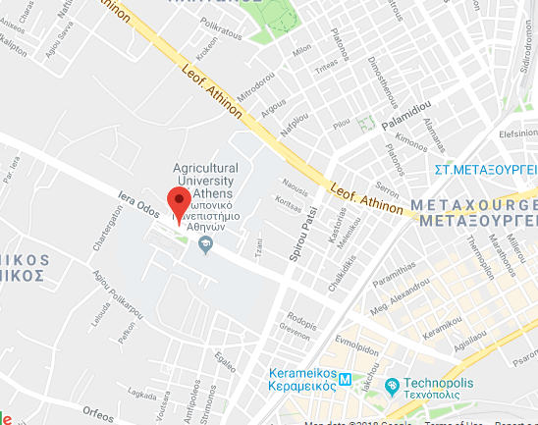**



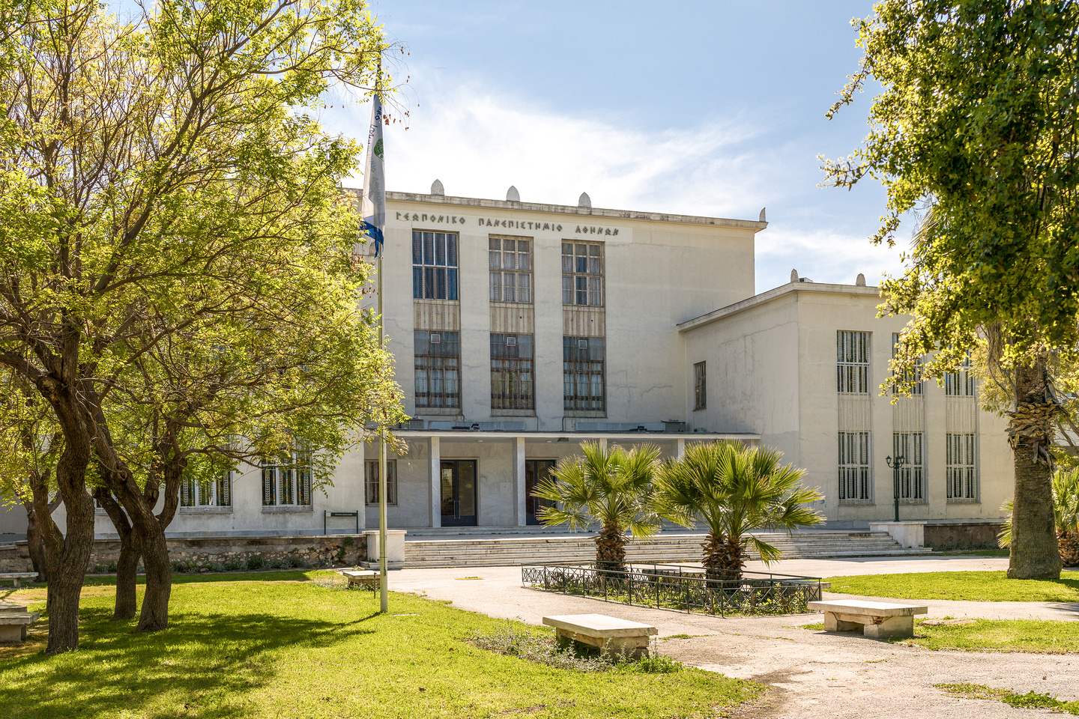

# Training Course Timings

## Schedule

|  |  |  |  |
| --- | --- | --- | --- |
| **Wednesday, 18th April 2018** | | | |
| 09:00 – 11:00 | **Tour to AUA premises** | | |
| 11:00 – 15:00 | **Visit to ΥΙΟTIS Company**  YIOTIS S.A. is a​ historic Greek​ food company located in Athens, with products that include baby foods, powder mixes for baking and cooking, chocolates, syrups and chilled desserts. The company was founded in 1930 and offered children food with ingredients from local crops such as corn and rice. From that day on, the company has never stopped innovating. The Company has one of the finest Research and Development Departments in the Greek Food Industry. The company meets the needs of the whole family, with a rich variety of innovative products that make them the homemaker’s "right hand" when it comes to cooking and baking at home. In addition to this, it has been steadily playing its part in strengthening the Greek economy by consistently implementing its investment plans. In 2014, the company invested in acquiring a new warehouse in Mandra, Attica, with a total area of ​​9,000 sq. m. and capacity for 5,500 pallet stacks. In 2015, YIOTIS S.A. continued its steady investment plan in Greece and completed the construction of its new factory in Agrinio, with a total area of ​​10,000 sq. m. In 2017 the construction of new company facilities was completed. These 1350 sq. m. facilities house the "Hellenic Research and Innovation Center" (HRIC), which gives the company the ability and the momentum to increase the checks and controls, it carries out on its Food Production. At the same time, the company is dynamically strengthening its presence in foreign markets in all five continents.  **ΥΙOTIS S.A.**  130, Kifissou Av.  GR-121 31, ATHENS GREECE  http://www.jotis.gr | | |
| **Thursday, 19th April 2018** | | | |
| 10:00 – 10:30 | **Welcome** | |  |
| 10:30-11:15 | **Basic Quality Concepts**   * Basic Quality Definitions * History Of Quality Control And Improvement | | Lina Tsakalou (CRETHIDEV) |
| 11:15 – 11:30 | Break | |  |
| 11:30 – 12:30 | **Introduction to Statistical Quality Control**   * Statistics Used In Quality * Statistical Definition of Quality * Design of Experiments * Statistical Process Control * Acceptance Sampling | | Prof. Sotirios Bersimis |
| 12:30 – 12:45 | Break | |  |
| 12:45 - 13:30 | **The Main Quality Tools**   * Check Sheets * Flowcharts * Cause And Effect (Fishbone) * Histograms * Scatter Diagrams * Pareto Charts * Run Charts / Control Charts | | Prof. Sotirios Bersimis |
| 13:30 – 13:45 | Break | |  |
| 13:45 - 14:30 | **The Main Quality Tools (continued)** | | Prof. Sotirios Bersimis |
| 14:30 – 14:45 | Break | |  |
| 14:45 – 15:30 | **Introduction to Process Capability**   * Process Distribution & Specifications * Quality Costs * Process Capability Indices (Cp) * Process Capability Indices (Cpk)   **Summary of the day - Discussion** | | Prof. Sotirios Bersimis |
| **Friday, 20th April 2018** | | | |
| 10:00 – 12:00 | | Tour to AUA premises |  |
| 12:15-13:00 | | **Introduction to Statistical Process Control**   * Basic Characteristics of Control Charts * Phases of Statistical Process Control * Control Charts for Variables * Average Run Length * Control Charts for Attributes | Prof. Sotirios Bersimis |
| 13:00 – 13:15 | | Break |  |
| 13:15-14:00 | | **Introduction to Statistical Process Control (continued)** | Prof. Sotirios Bersimis |
| 14:00 – 14:15 | | Break |  |
| 14:15-15:00 | | **Introduction to Statistical Process Control (continued)**  **Summary of the day - Discussion** | Prof. Sotirios Bersimis |
| 15:00-15:30 | | **Evaluation** |  |
| **Saturday, 21st April 2018** | | | |
| 10:00 – 12:00 | | **Case studies** | Lina Tsakalou (CRETHIDEV) |
| 12:00 – 12:15 | | Break |  |
| 12:15-14:00 | | **Summary of the day - Discussion** | Lina Tsakalou (CRETHIDEV) |

## Teachers

* **Ms Lina Tsakalou**

Lina Tsakalou is a Chemical Engineer BSc is a Project Manager for CRE.THI.DEV where she has served as the Project Quality Manager for several Erasmus+ projects. She has worked at ELKEDE Technology & Design Centre SA at its Quality Department and the Quality Control Laboratory, in charge of the Product Certification Office. During the same time she also prepared the Certification Quality System for Accreditation assessment according to the EN45011 standard and has served for many years as an Assistant Quality Manager for the Quality Control Laboratory of ELKEDE. During her work at the Laboratory, she was in charge of the coordination of the internal laboratory quality control in the scope of the accreditation of the Laboratory according to EN ISO 17025. She has also been the main trainer on the subject “Introduction to the Requirements of ISO 9001”, for entrepreneurs from Moldavia, Georgia, Ukraine, Serbia, Albania, and Egypt, in cooperation with the Training Centre of the National Bank of Greece & EOMMEX.

* **Prof. Sotirios Bersimis**

Bersimis Sotirios is an Assistant Professor at the Statistics and Insurance Science Department of the University of Piraeus, where he has been providing his academic services since 2010. He is a PhD holder in Statistics and Probability, from the Statistics and Insurance Science Department of the University of Piraeus. He also holds an MSc in Statistics from Athens University of Economics and Business and a BSc in Statistics and Insurance Science from the University of Piraeus. His doctoral research has been funded by a scholarship from the Hellenic General Secretary of Research and Technology. He has also been granted a post-doctoral fellow scholarship by the Hellenic State Scholarships Foundation. His teaching at the University of Piraeus involves “Statistics” in the Department of Economics, in the Department of Industrial Management and Technology, “Biostatistics” and “Statistical Quality Control” in the Department of Statistics and Insurance Science as well as “Biostatistics and Epidemiology” and “Clinical trials” both in a post-graduate level in the Statistics and Insurance Science Department and “Business Intelligence / Business Analytics” in a post-graduate level in the Department of Business Administration. Since December 15th 2015, he has been appointed as President of the Hellenic Organization for Health Care Services Provision (EOPYY), which is a governmental agency responsible for providing health care services to all Greek citizens.

[http://www.unipi.gr/unipi/en/sbersim.html](https://www.linkedin.com/in/sotiris-bersimis-7564465/)

[https://www.linkedin.com/in/sotiris-bersimis-7564465/](http://www.unipi.gr/unipi/en/sbersim.html)

# List of Participants

The training seminar eventually was attended by 6 trainees (out of 19 registered). In the following table the persons that did not attend are noted.

|  |  |  |  |  |
| --- | --- | --- | --- | --- |
| **UNIVERSITY** | **No.** | **TITLE** | **FULL NAME** |  |
| **Jordan University of Science**  **and Technology (JUST)** | **1** | Mr. | JASER KHALAF QASEM MAHASNEH | Did not attend |
| **2** | Mr. | BASHAR HAMMAD ALI AL-DWAIRI | Did not attend |
| **3** | Mr. | RA’ED KHALED BDAIWI AL-ZOUBI | Did not attend |
| **4** | Dr. | KHALID IZEDDIN BARAKAT ALKHATIB | Did not attend |
| **Jerash University (JU)** | **5** | Dr. | EBRAHEEM SULIMAN YOUSUF AL TAHA'T | Did not attend |
| **6** | Dr. | AHMED MOHAMMD MAHMOUD AL-HAWAMDEH | Did not attend |
| **The Jordan Food and**  **Drug Administration (JFDA)** | **7** | Eng. | SAFA’A REDWAN ASAD AL-SMADI | Attended |
| **8** | Eng. | NAWAL AHMAD ABDELQADER ALSAKARNEH | Attended |
| **9** | Eng. | OMAR M. A. ADWAN | Attended |
| **10** | Eng. | RA‘AFAT KHALAF ALI ALHALAKI | Attended |
| **University of Jordan (UJ)** | **11** | Prof. | MOHAMMAD ALI MOHAMMAD ALOMARI | Did not attend |
| **12** | Prof. | (MOHAMMED ISAM) AHMAD MOHAMMED YAMANI | Did not attend |
| **13** | Prof. | MAHER MAHMMUD BASHEER DABBAS | Did not attend |
| **14** | Mr. | RA`ED ABDULELAH OTHMAN ALSAIED AHMAD | Did not attend |
| **Al-Balqa` Applied**  **University (BAU)** | **15** | Eng. | BASIM ABDEL RAHMAN AHMAD ALDABABSEH | Did not attend |
| **16** | Eng. | ASEEL KHALED MOHAMMAD ALRAHAHLEH | Did not attend |
| **17** | Eng. | MOHAMMED NOURI ABDALLAH ABU HAZEEM | Attended |
| **18** | Eng. | LAMA MOHAMMAD AHMAD ABU HAMOUR | Did not attend |
| **19** | Dr. | MAHDI AHMAD MUSA NISIRAT | Attended |

# Signatures

There were some trainees who signed for more days of the training by accident. The signatures for the days that these trainees did not attend have been erased with a red X.

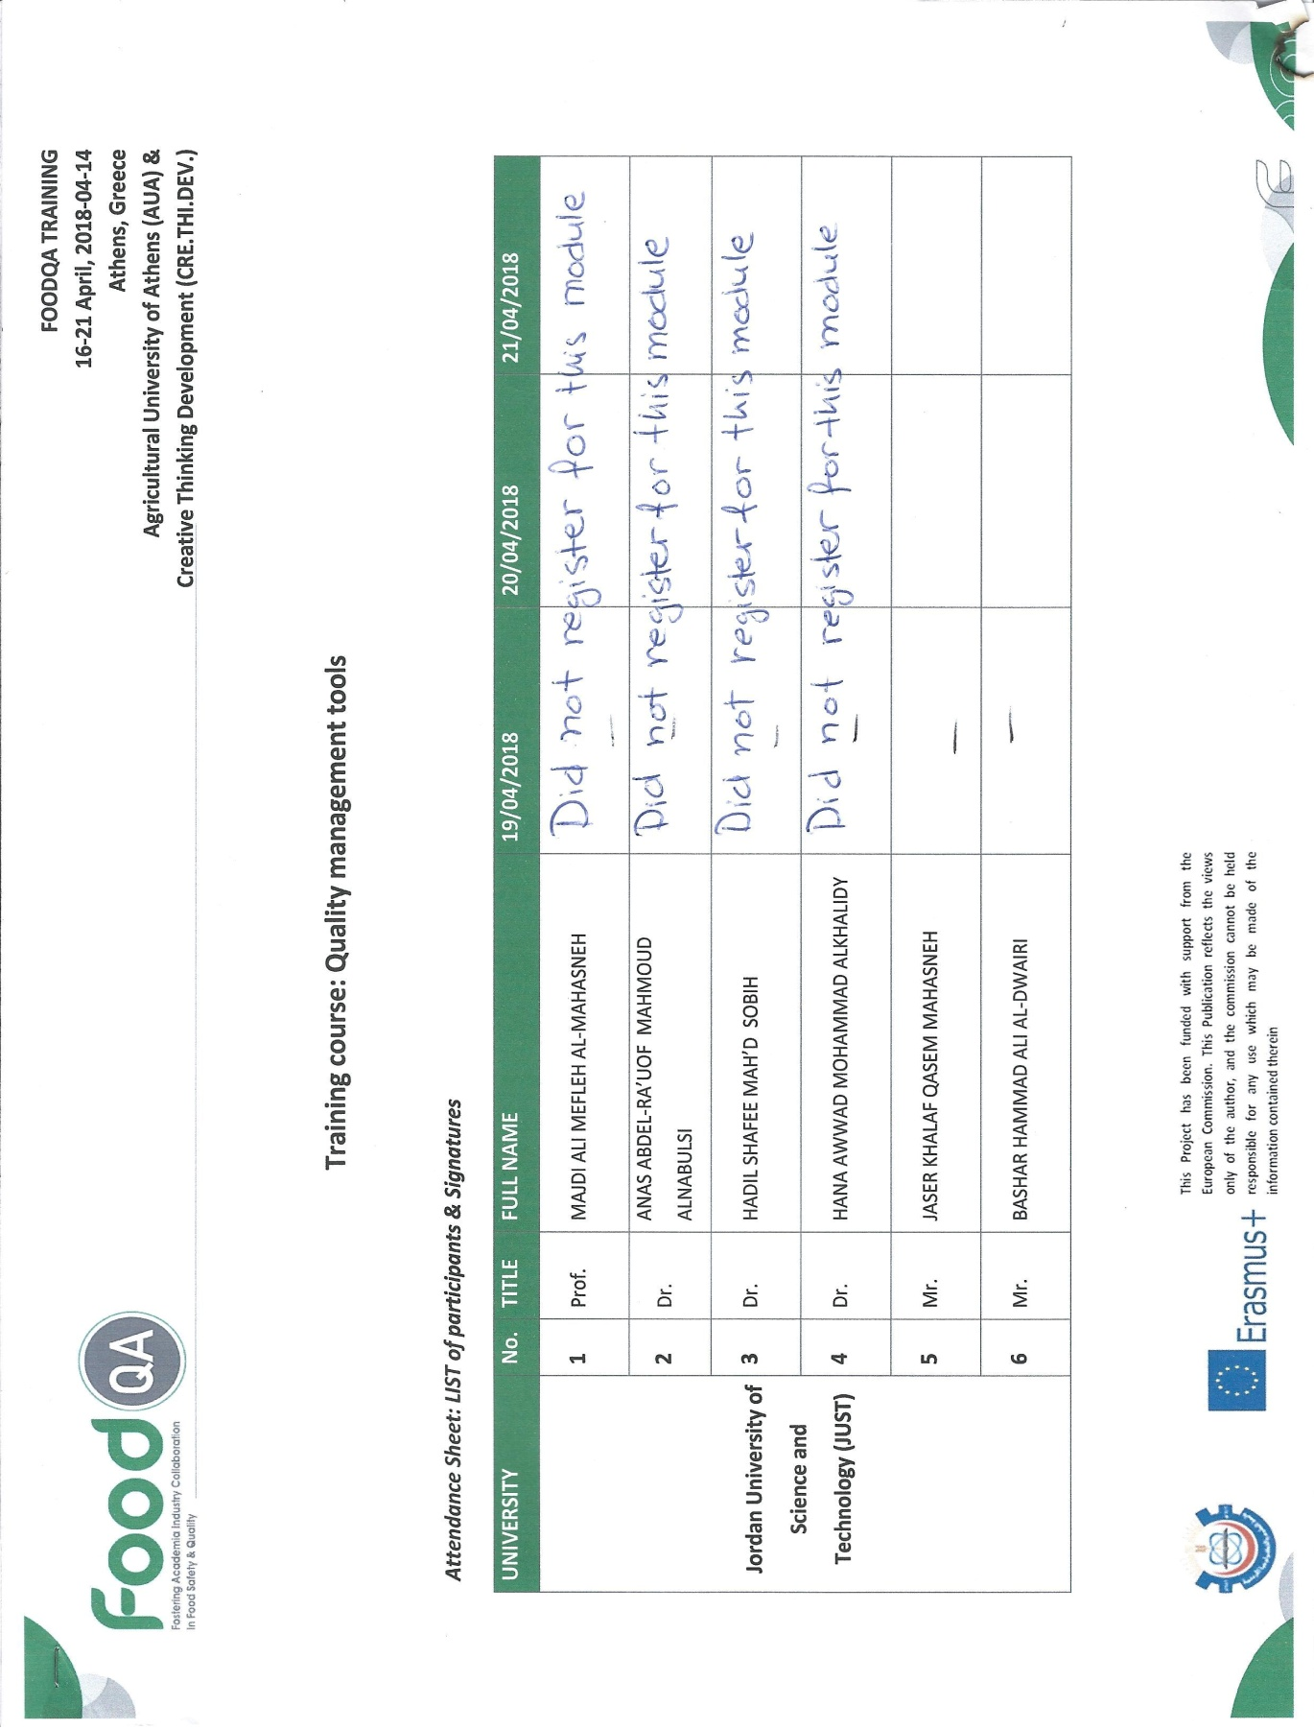

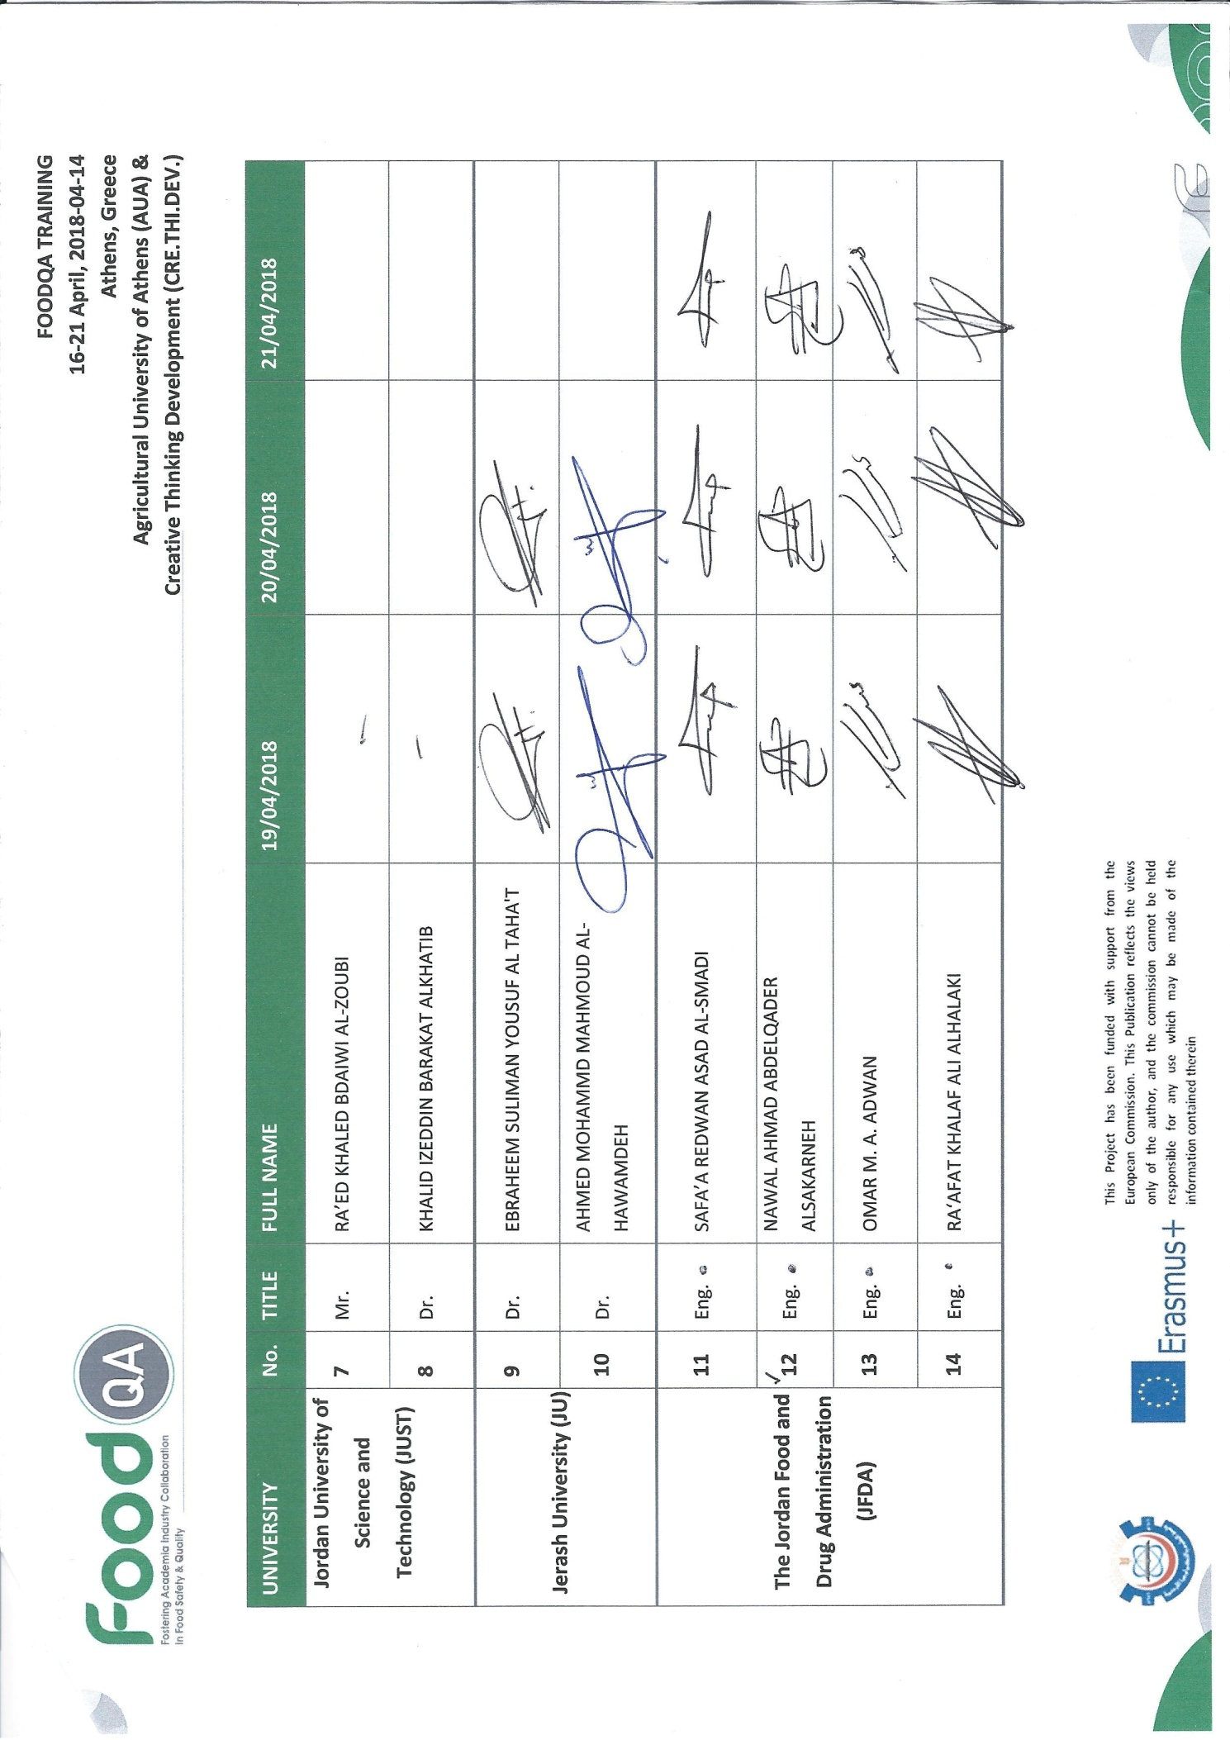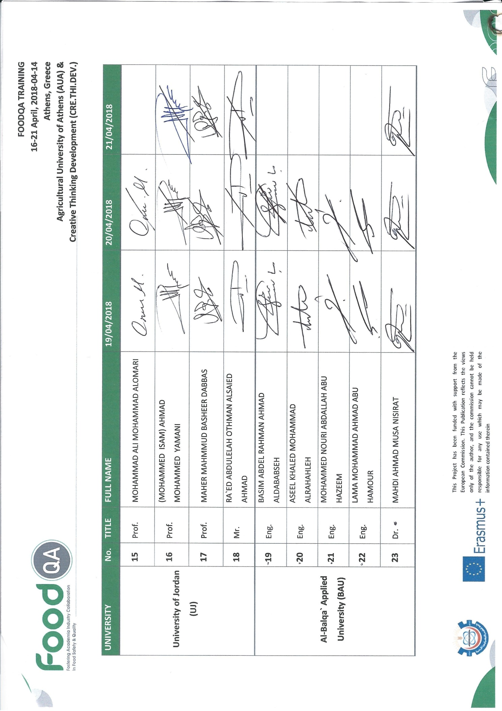

# List of Additional Training Materials

|  |  |  |
| --- | --- | --- |
| DAY 1 | INTRODUCTION TO QUALITY CONTROL (HISTORY & DEFINITIONS) | LINA TSAKALOU |
| STATISTICAL QUALITY CONTROL PART 1:  QUALITY  QUALITY DIMENSIONS AND CHARACTERISTICS  PRODUCTION PHASES &  TECHNICS OF STATISTICAL QUALITY CONTROL  BASIC STATISTICS  THE MAGNIFICENT SEVEN  UNDERSTANDING VARIABILITY  PROCESS CAPABILITY | PROF. SOTIRIOS BERSIMIS |
| DAY 2 | STATISTICAL QUALITY CONTROL PART 2:  STATISTICAL BASIS OF THE CONTROL CHART  CONTROL CHART FOR VARIABLES  CONTROL CHARTS FOR INDIVIDUAL OBSERVATIONS  CONTROL CHARTS FOR ATTRIBUTES | PROF. SOTIRIOS BERSIMIS |
| DAY 3 | EXAMPLES | PROF. SOTIRIOS BERSIMIS |

# Assessment

The final assessment of the acquired knowledge was carried out using a questionnaire made of 10 questions.

## QMT_Training assessment-1.jpgTraining Assessment Questionnaire

#### QMT_Training assessment-2.jpg

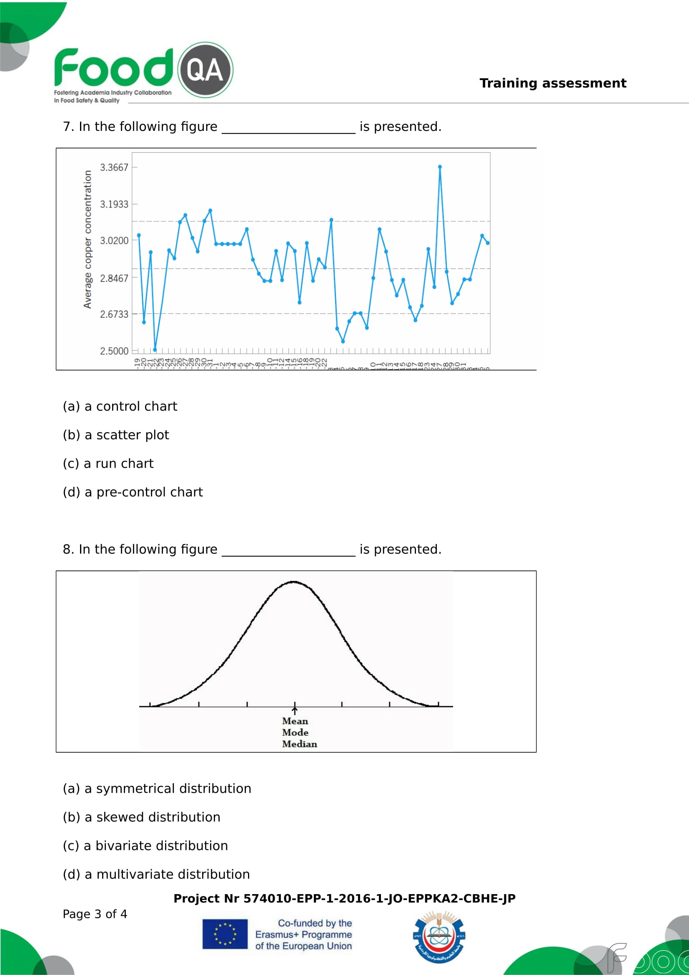

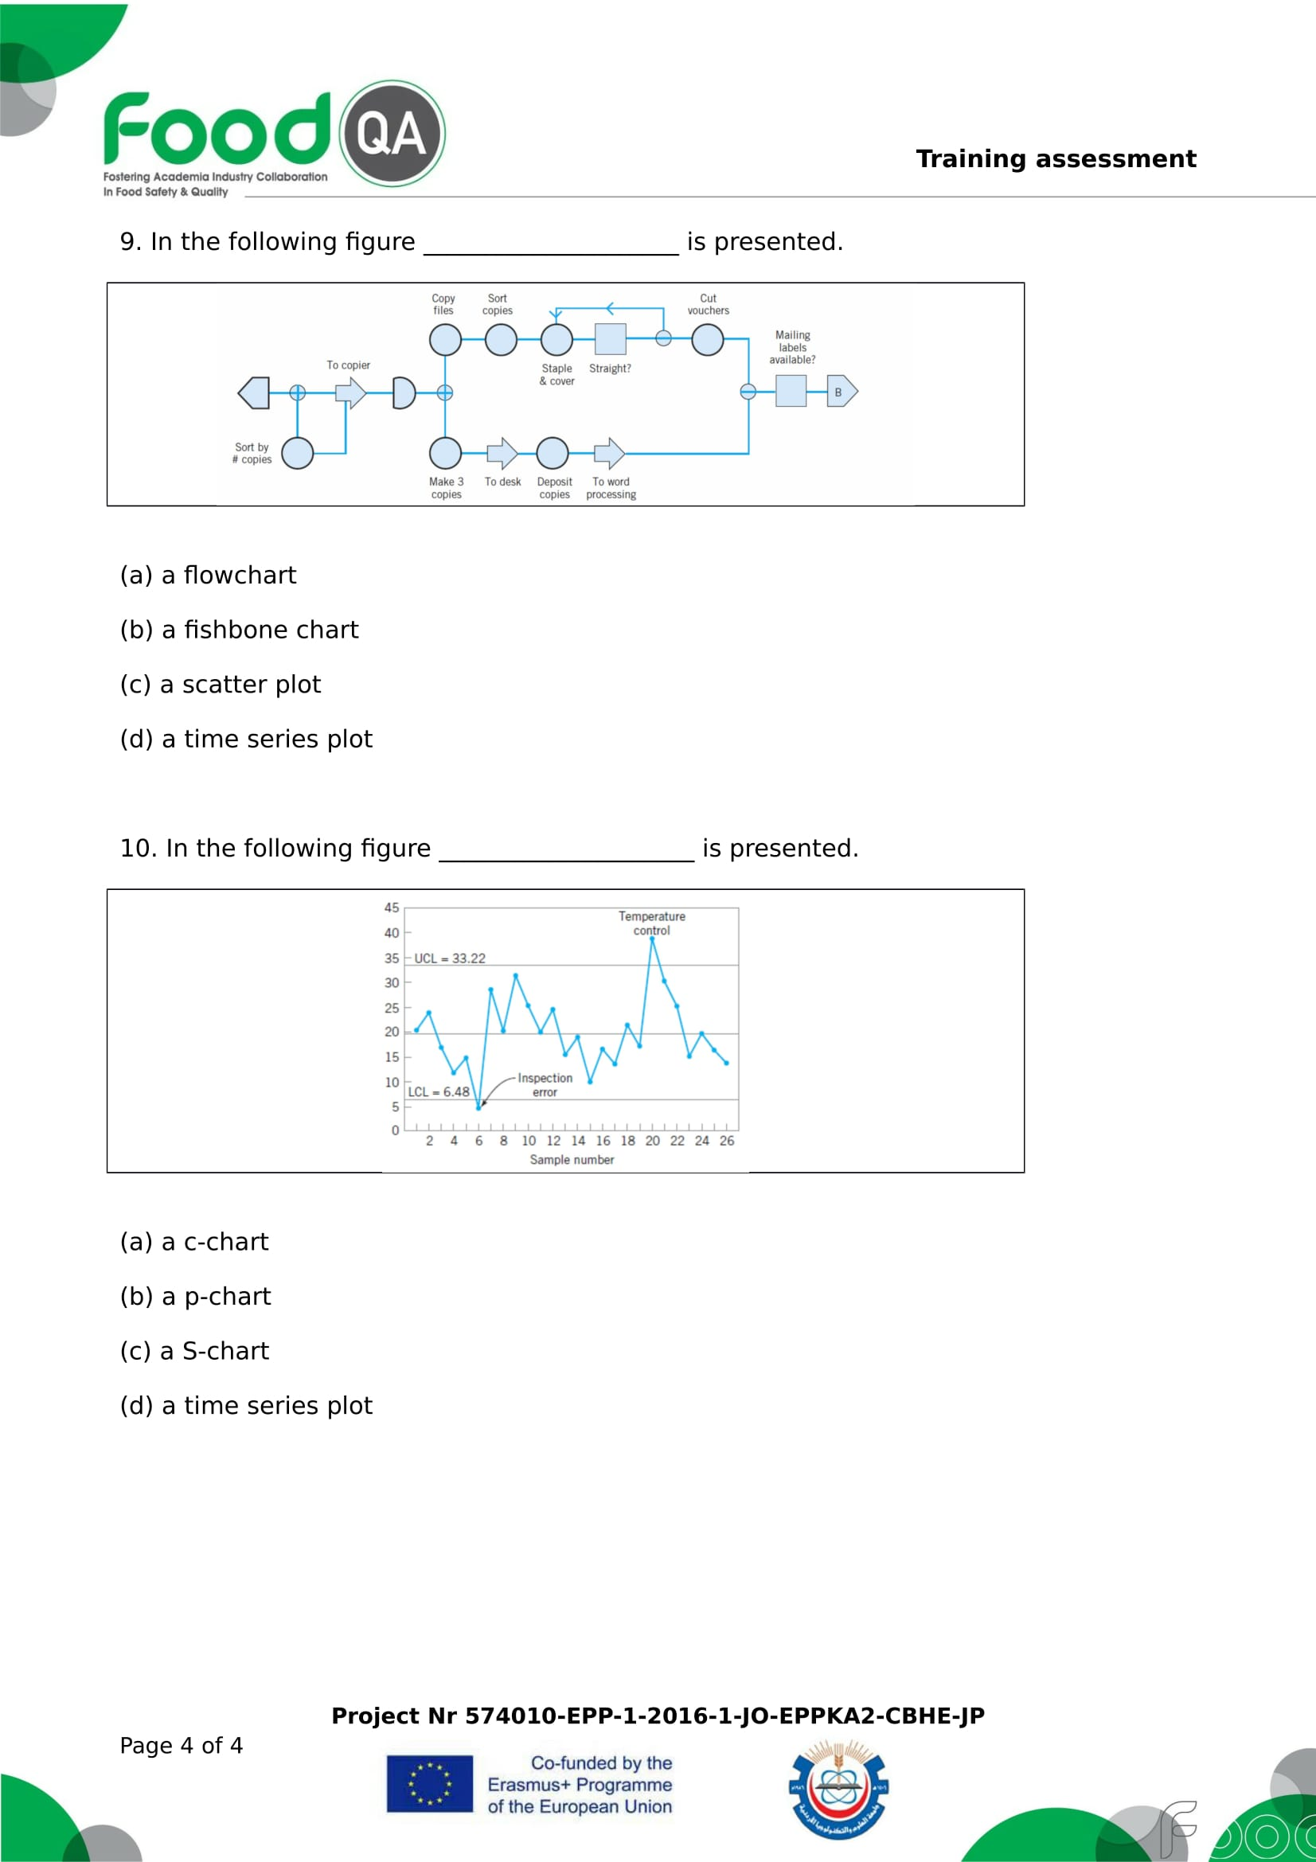

## Assessment Results

All trainees have taken the exam, with average correct responses to questions 66,7%. All participants had correct responses above 60%.

# Pictures

1. At the Fish, Microbiology and Dairy Laboratories, AUA

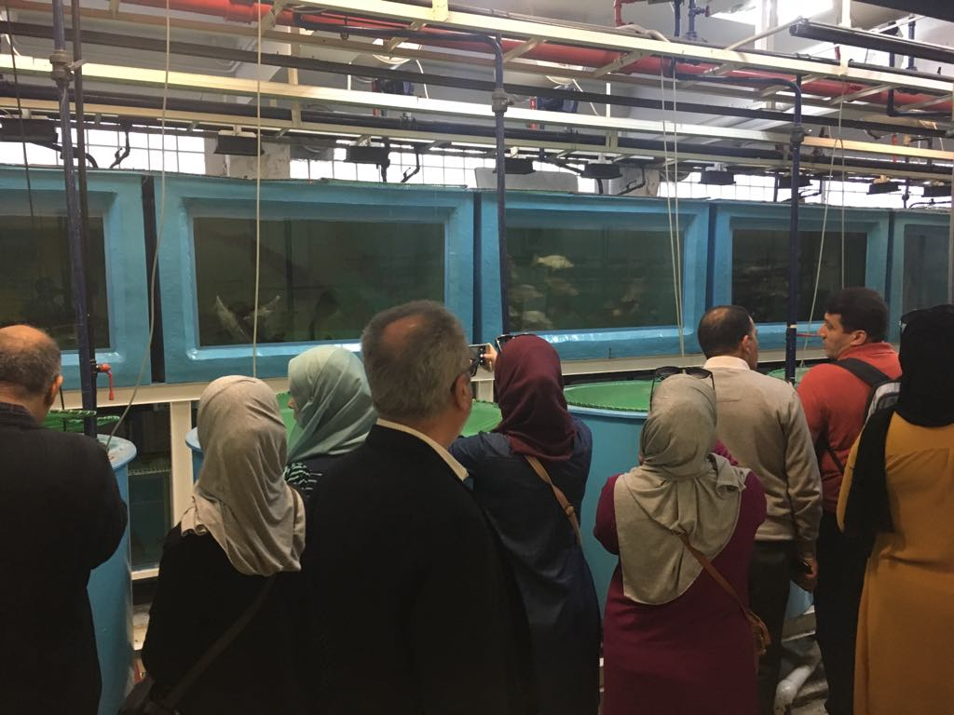

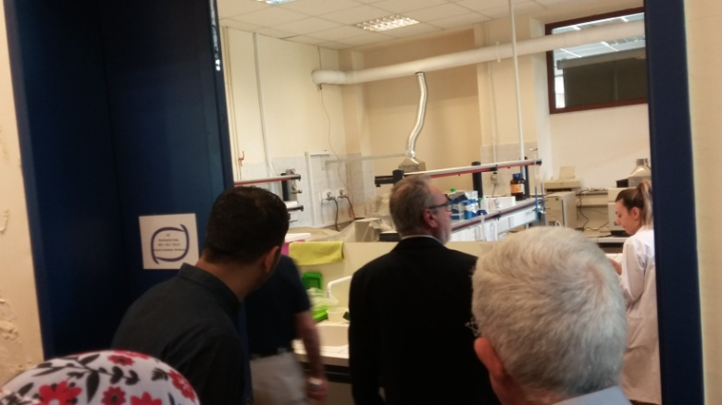

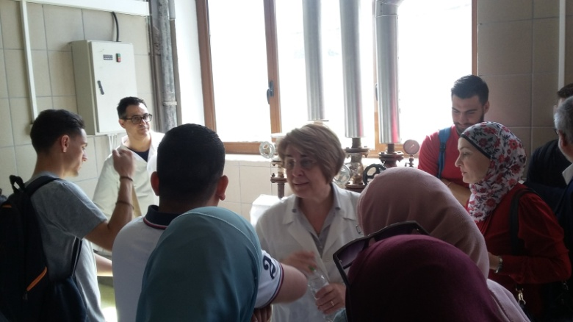

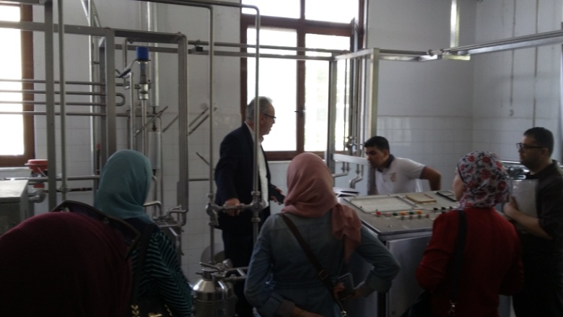

1. At the tour and presentations in YOTIS facilities:

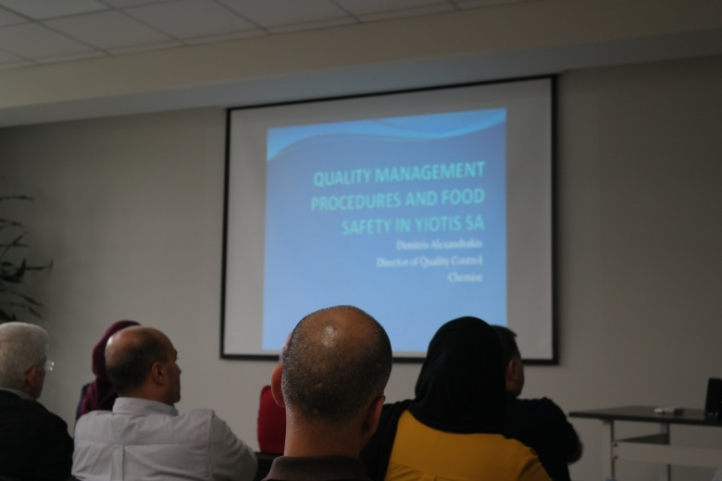

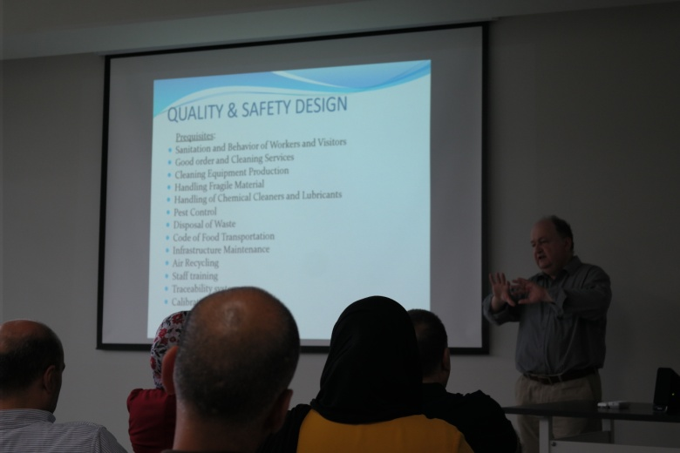

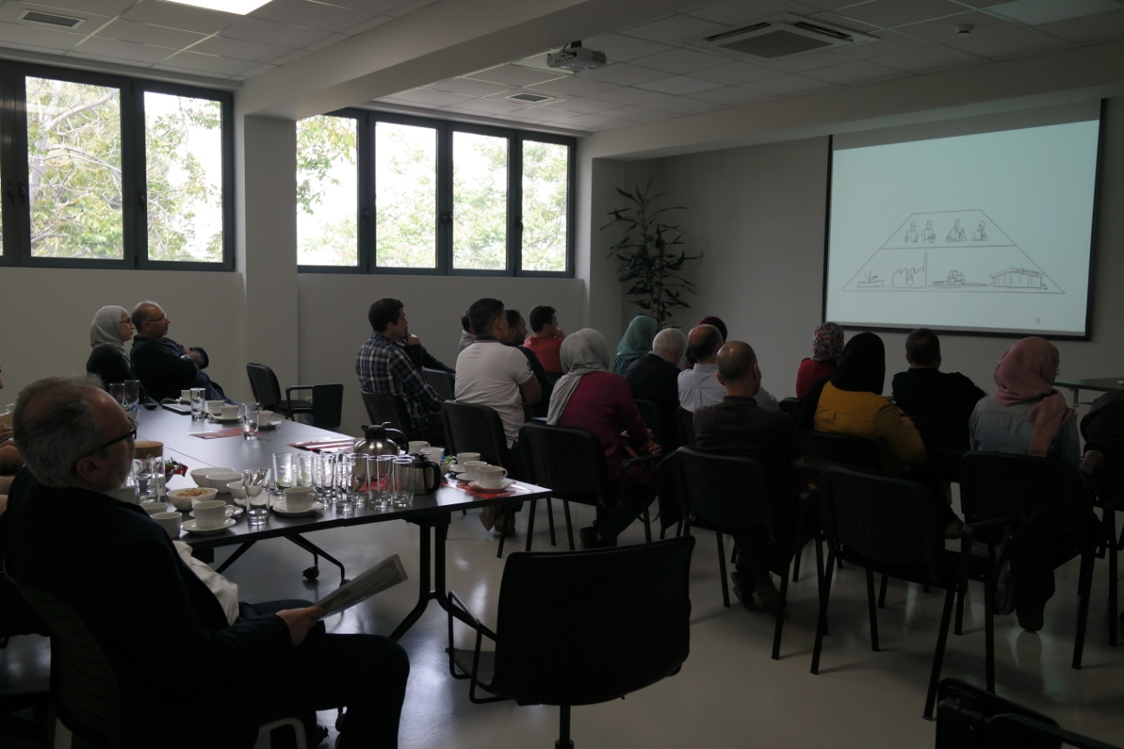

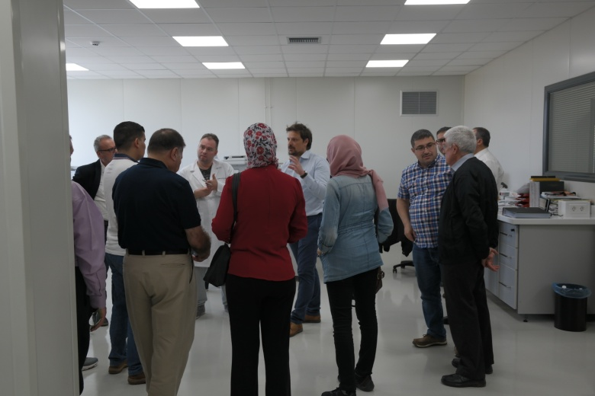

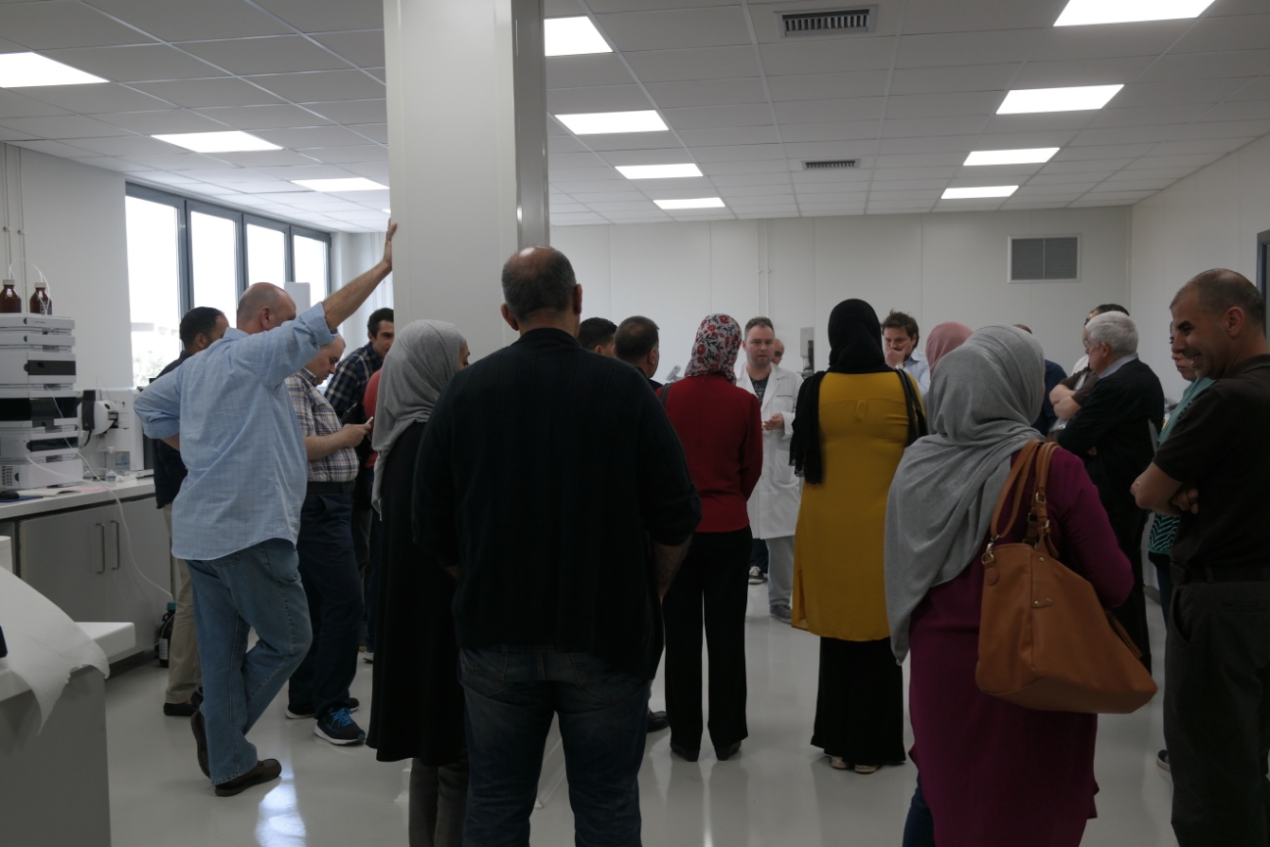

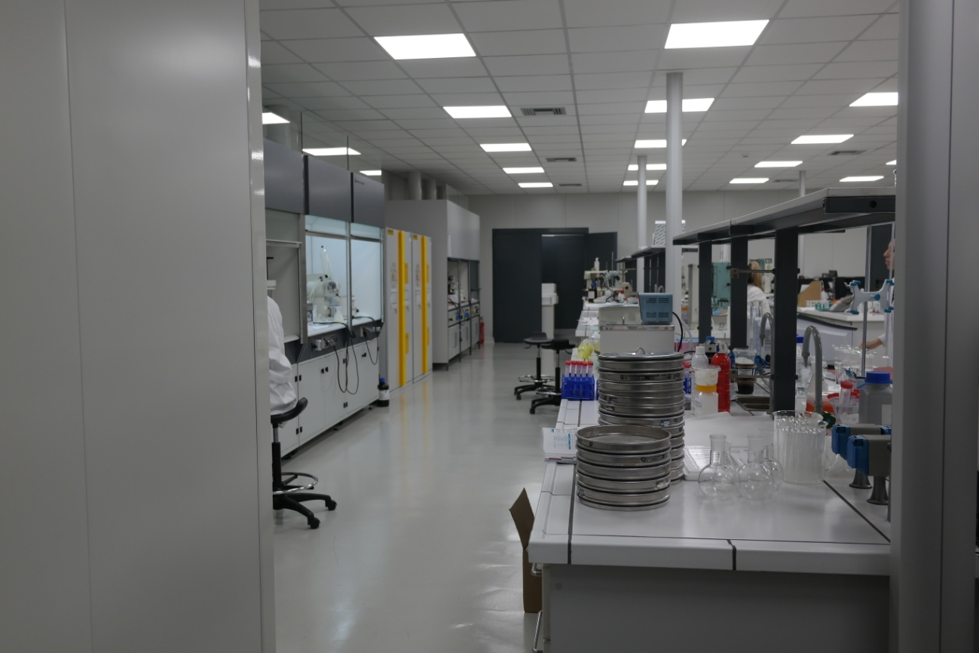

1. Training Sessions with Ms Lina Tsakalou & Prof. Sotirios Bersimis

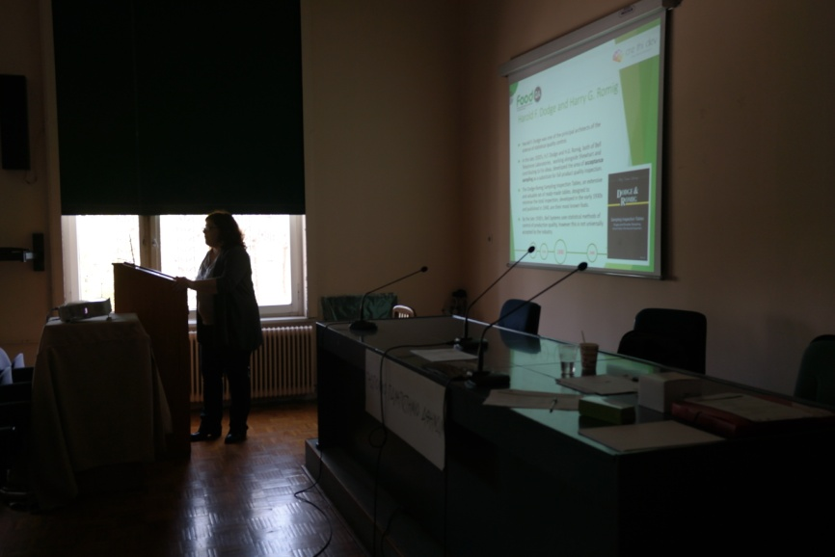

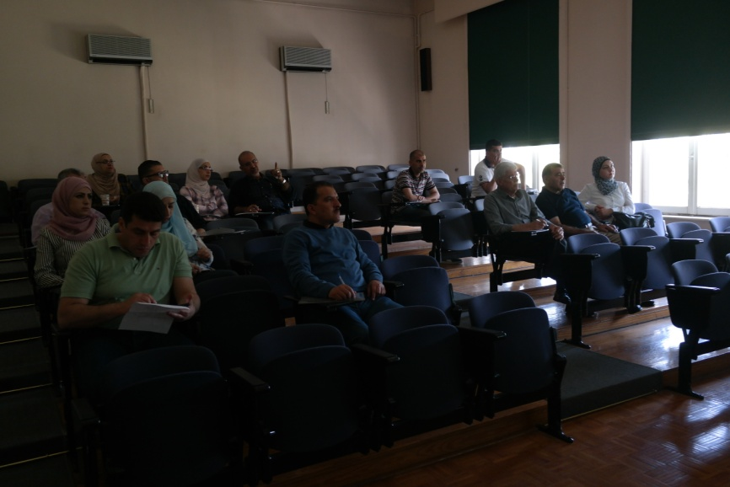

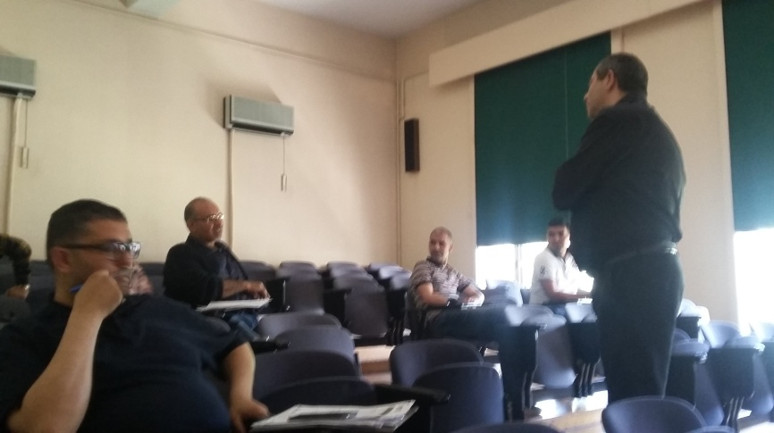

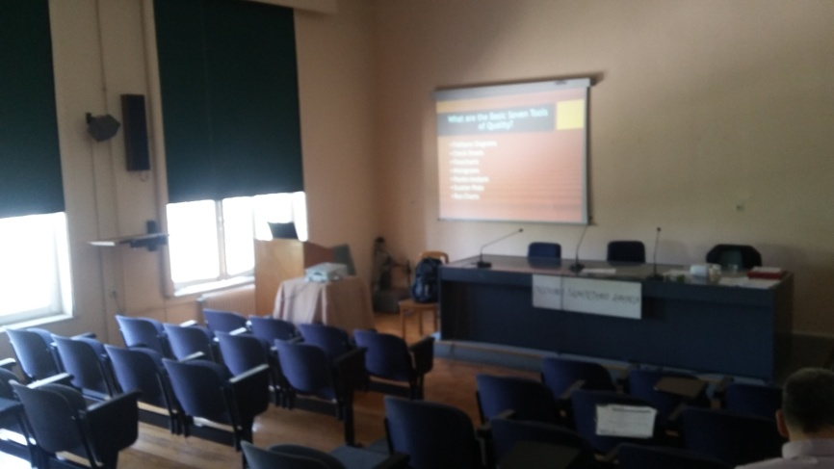

# Training Evaluation

**Work Package:** *2-Development of training courses*

**Seminar/Training Course Title:** *Quality Management Tools*

**Location of training:** *Athens, Greece*

**Date:** *18-22 April*

| *Please answer each question with a grade between 1-5, where 1 is Fully disagree and 5 is Fully agree.* | **weighted average** |
| --- | --- |
| 1. **Please rate the overall training experience.** |  |
| 1. The training was well planned and organised. | 87,0% |
| 1. The training facilities were adequate and comfortable. | 90,0% |
| 1. The technical resources used were satisfactory. | 83,0% |
| 1. Materials provided were helpful. | 90,0% |
| 1. The objectives of the training were clearly defined and met. | 83,0% |
| 1. The training content was well organised. | 77,0% |
| 1. The topics of the training were clear and easy to follow. | 87,0% |
| 1. Length of training was sufficient. | 70,0% |
| 1. The training enhanced my understanding on the subject. | 80,0% |
| 1. Training was relevant to my needs. | 83,0% |
| 1. The training will be useful to my work and my professional growth. | 90,0% |
| 1. Training met my expectations. | 80,0% |
| 1. **What is your opinion of the Trainers, regarding:** |  |
| 1. The trainer was knowledgeable about the training topic. | 83,0% |
| 1. The trainer had the ability to explain and illustrate concepts. | 87,0% |
| 1. The topics were presented in a clear and understandable manner. | 87,0% |
| 1. The trainer encouraged participation, interaction and answered questions clearly. | 90,0% |
| 1. The trainer’s communication style kept me focused and interested. | 83,0% |

|  |  |  |
| --- | --- | --- |
| 1. **Was this training appropriate for your level of experience?** | **Yes**  100% | **No**  0% |
| 1. **Which topics were not covered or insufficiently covered, in your opinion?**  * ISO was not covered well. * All topics of the course were covered. * Still it's a standard and should be given before. * All. | | |
| 1. **Which topics were not relevant in your opinion?**  * No topics were not relevant. * The statistical part. * Quality Tools, but it was good and the trainer is also good. * None. | | |
| 1. **What did you like best about the training?**  * Dr. Bersimis Sotiris is an excellent trainer. * I think you may add signature of trainee at each entry and exit, so you can monitor attendance perfectly. * The Quality Management Tools. * All things were good. * Dr Bersimis of how he was relating the subject together. * Dr Bersimis is an excellent trainer. * Dr Bersimis' method of interconnecting the material. | | |
| 1. **What suggestions or comments do you have for making the program more effective?**  * Monitoring attendance and the materials could be given for the trainees before the training, so the trainees could be prepared for the course. Special thanks for all persons who were preparing and teaching this course. | | |

## Overall Conclusions

* The overall results of the evaluation of the training are positive as the majority of the trainees agree that the objectives of the training were clearly defined and met, the training enhanced understanding on the subject and that the training was relevant to their needs.
* 50% of the respondents believe that the length of training was sufficient, while 33% had a neutral response to this question.
* All agree that the training was well planned and organized, the facilities were adequate and comfortable, and the materials provided were helpful and that the training will be useful to their work as well as to their professional growth.
* The majority agree that the technical resources used were satisfactory, the training content was well organized and that the topics of the training were clear and easy to follow.
* The majority agree that the training workshop met their expectations.
* The majority of the participants consider that the trainers were knowledgeable about the training topic and that they had the ability to explain and illustrate concepts.
* The majority believe that the topics were presented in a clear and understandable manner and that the trainers encouraged participation, interaction and answered questions clearly.
* The majority stressed that the trainers’ communication style kept them focused and interested.
* All consider that the level of training was appropriate for their level of experience.
* All stressed that the trainers of the subject *Quality Management Tools*, were very qualified.

# Annexes

## Annex 1: Introduction to Quality Control (History & Definitions)

## Annex 2: Statistical Quality Control Part 1

## Annex 3: Statistical Quality Control Part 2